LAB No 12
Implementation of Reinforcement Learning Part 1

Experiment: CartPole Environment using Gymnasium & Pygame

Lab Objectives
After completing this lab, students will be able to:
- Understand the Reinforcement Learning interaction loop
- Use Gymnasium environments
- Visualize agent behavior using Pygame
- Interpret states, actions, rewards, and episodes
- Modify and analyze RL environment parameters
import gymnasium as gym
import pygame

env = gym.make("CartPole-v1", render_mode="human")

font = None

for episode in range(1, 20):
score = 0
state, info = env.reset()
done = False

while not done:
action = env.action_space.sample()
state, reward, terminated, truncated, info = env.step(action)
done = terminated or truncated
score += reward

if font is None:
pygame.font.init()
font = pygame.font.SysFont("Arial", 24)

surface = pygame.display.get_surface()
text = font.render(f"Score: {int(score)}", True, (255, 0, 0))
surface.blit(text, (10, 10))
pygame.display.update()

print(f"Episode {episode} Score: {score}")

env.close()
pygame.quit()

Lab Questions (Conceptual Understanding)
Q1.
What is Reinforcement Learning? Identify the agent, environment, state, action, and reward in the given code.
Answer:
Reinforcement Learning is a type of machine learning in which an agent interacts with an environment, takes actions, and learns from rewards. The objective is to learn a policy that maximizes the total reward over time.
Identification Table:
Component | Description in Code
Agent | The program that selects actions
Environment | CartPole-v1
State | Cart position, cart velocity, pole angle, pole velocity
Action | Move cart left or right
Reward | +1 for each successful step

Q2.
Explain the purpose of the following line:
env = gym.make("CartPole-v1", render_mode="human")
Answer:
This line creates the CartPole environment using Gym. The render_mode="human" option enables visual rendering so the environment is displayed in a window where the cart and pole movement can be observed.
Q3.
What does env.reset() return? Why are two values returned?
Answer:
env.reset() returns two values: the initial observation and additional environment information. The observation represents the starting state, while the second value provides extra details related to the environment setup.
Q4.
Explain the difference between:
terminated
truncated
Answer:
Aspect | terminated | truncated
Reason for ending | Episode ends because the environment’s success or failure condition is met | Episode ends because an external limit such as time or steps is reached
Task status | Task logically finishes | Task does not logically finish
Agent performance | Indicates correct or incorrect performance | Does not reflect agent performance
Environment rule | Defined by environment dynamics | Defined by imposed constraints
Learning impact | Helps agent understand success or failure | Mainly limits episode length

Q5.
What is the role of the variable score? How is it calculated?
Answer:
The variable score stores the total reward obtained in one episode. Each time the agent takes a valid step, the reward is added to the score. A higher score indicates better performance.
Q6.
Why is action = env.action_space.sample() used?
Is this an intelligent agent? Justify your answer.
- It selects a random action from the action space
- It allows basic exploration of the environment
- No learning or decision-making logic is used

Q7.
Explain how Pygame is used to display the score on the screen.
Answer:
Pygame is used to create a font object that renders the score as text. This text is then drawn onto the game window at a fixed position, and the screen is refreshed continuously to show the updated score.
Q8.
What happens if the pygame.display.update() line is removed?
Answer:
If pygame.display.update() is removed, changes made to the screen will not appear. The score and graphics may update internally, but nothing new will be visible to the user.

Lab Tasks
Task 1: Modify Number of Episodes
Change the number of episodes from 20 to 50 and observe:
- How the score varies across episodes
- Whether performance improves or remains random
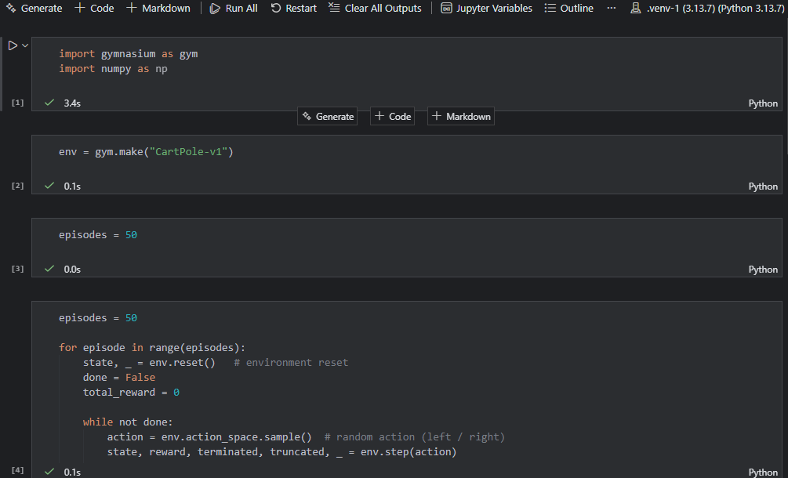
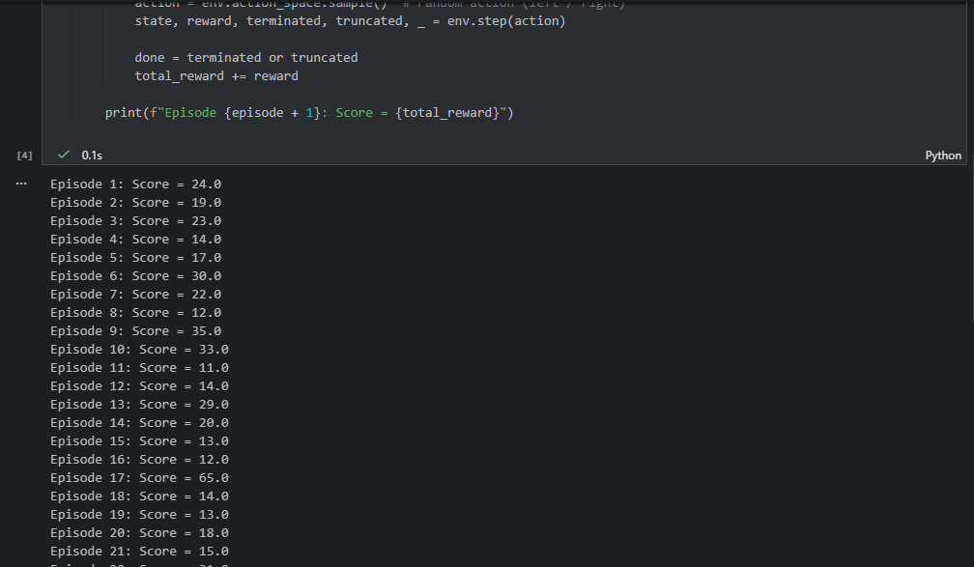
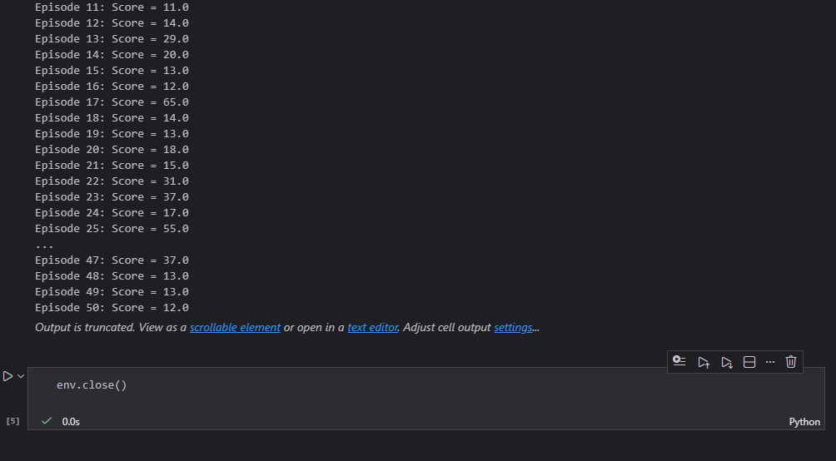
Task 2: Display Episode Number on Screen
Modify the code to show:
Episode: X | Score: Y
on the CartPole window.
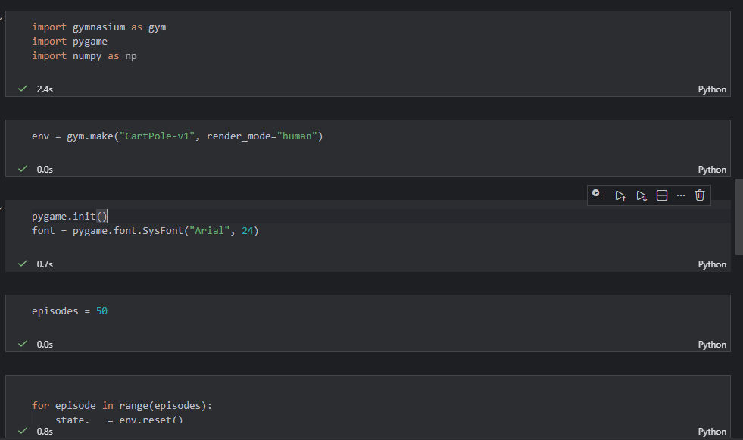
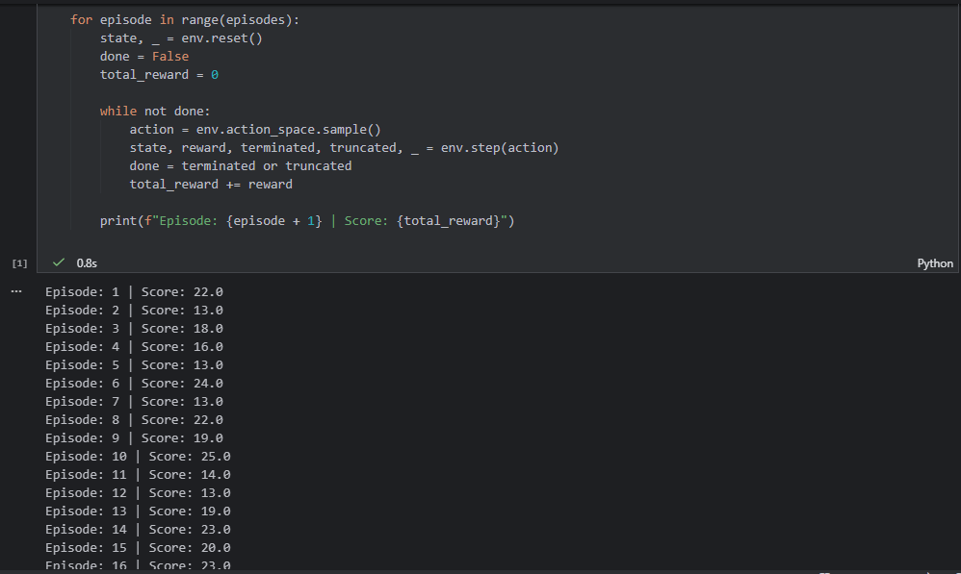
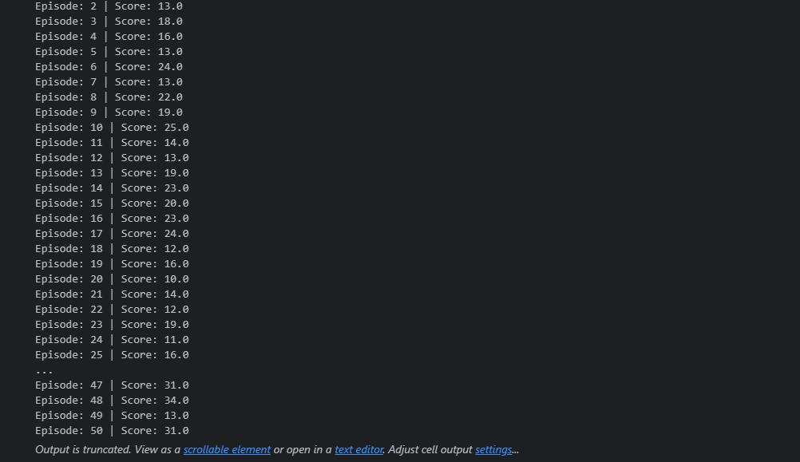

Task 3: Change Text Color and Position
- Change score text color from red to green
- Display it at position (200, 20)
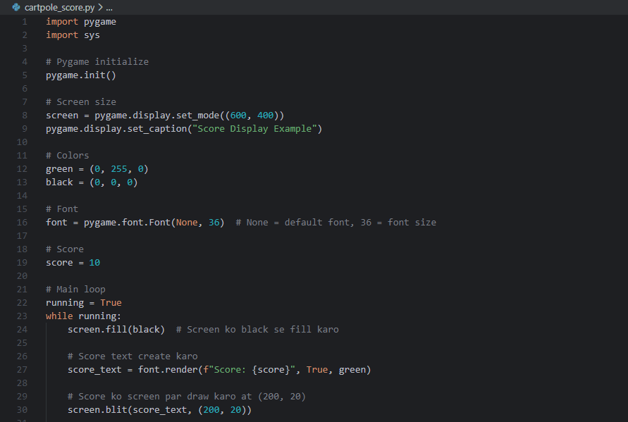
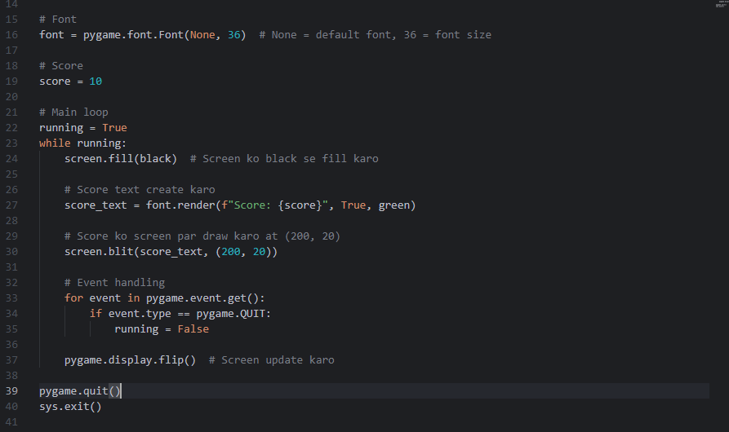
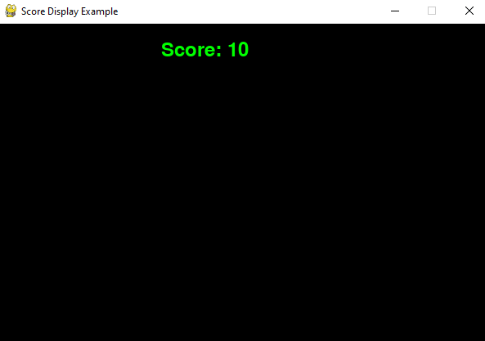

Task 4: Print Maximum Score
After all episodes finish:
- Store all episode scores
- Print the maximum score achieved
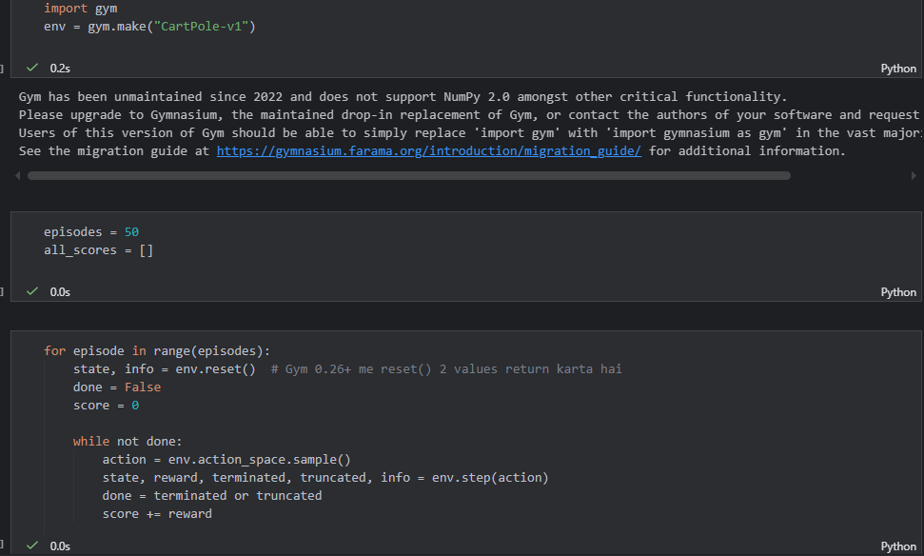
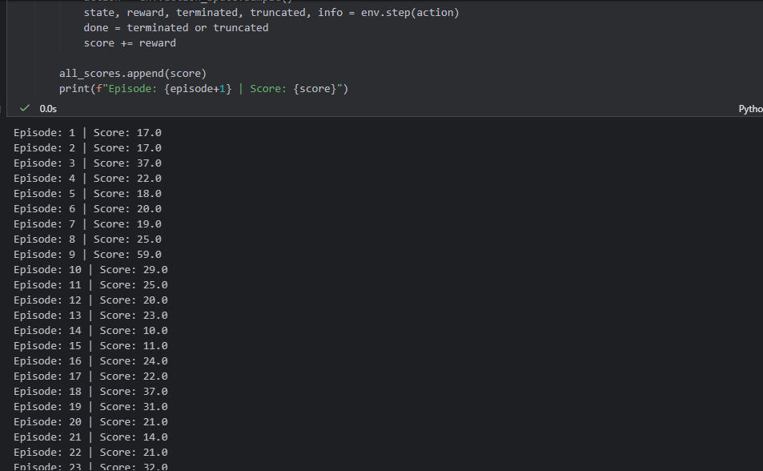
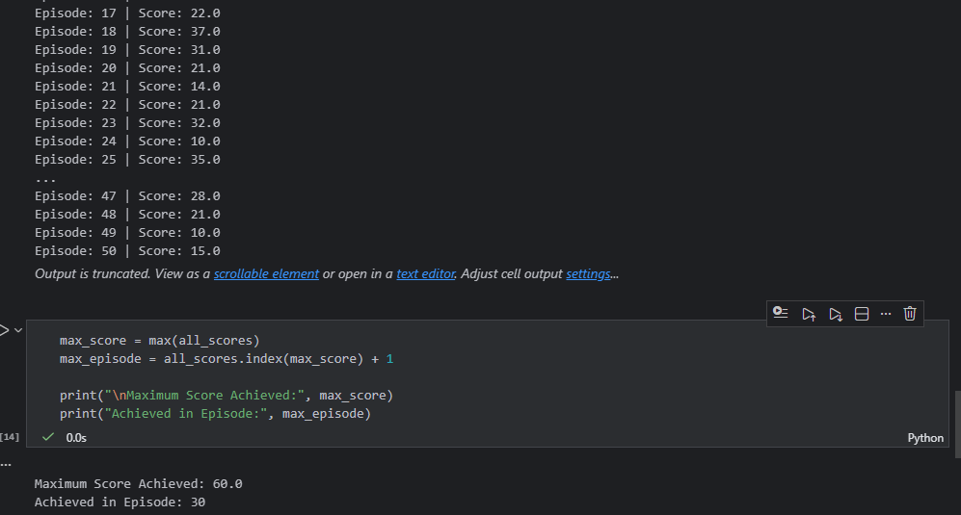
Task 5: Slow Down the Environment
Insert a small delay using:
pygame.time.delay(20)
Observe the effect on visualization.
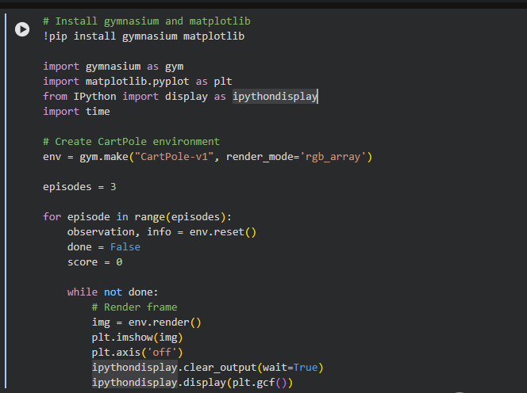
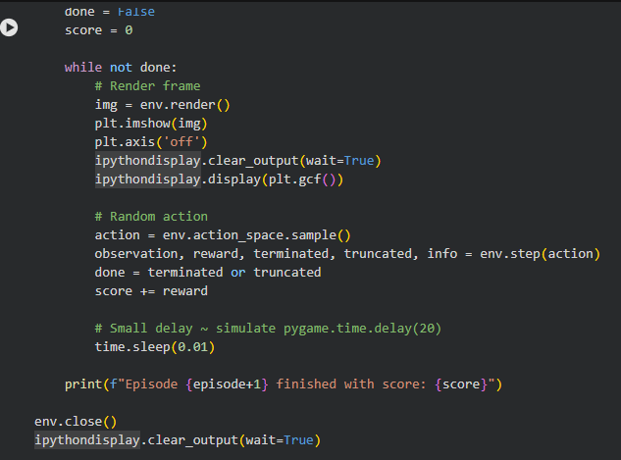
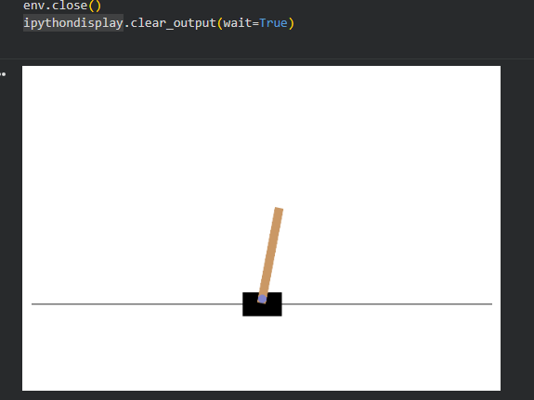
Task 6: Replace CartPole with MountainCar
Change the environment to:
env = gym.make("MountainCar-v0", render_mode="human")
Compare:
- Reward behavior
- Episode termination condition
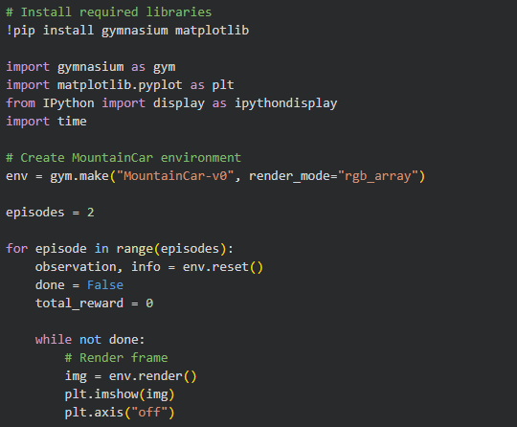
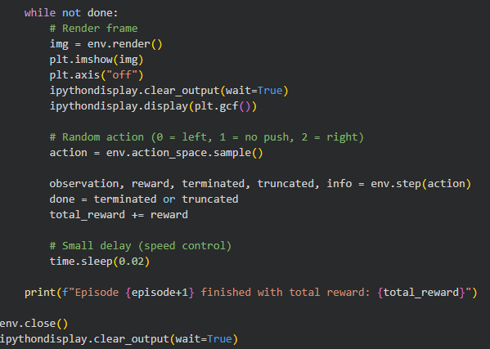
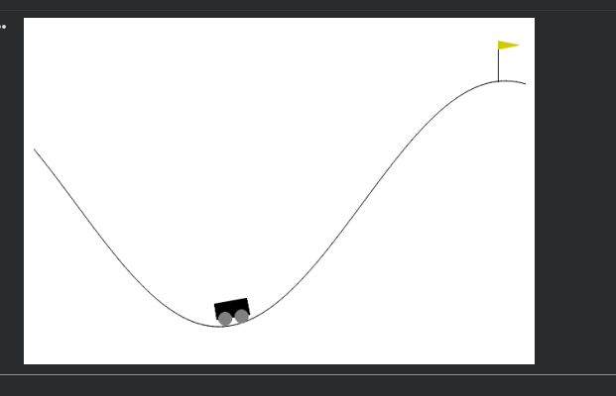
Task 7: Identify State Variables
Print the state vector and answer:
- How many state variables are there?
- What does each variable represent?
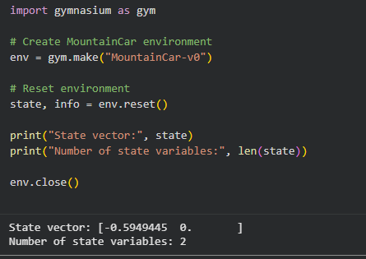
Task 8 (Advanced): Rule-Based Action
Replace random action with:
if state[2] > 0:
action = 1
else:
action = 0
random actions were replaced with a rule-based policy. If the pole angle is positive, the cart moves right; otherwise, it moves left. This rule helps in balancing the pole better than random actions and increases the episode score
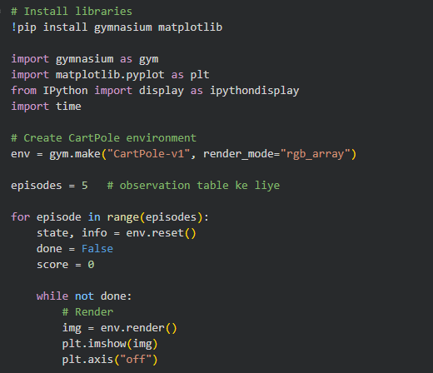
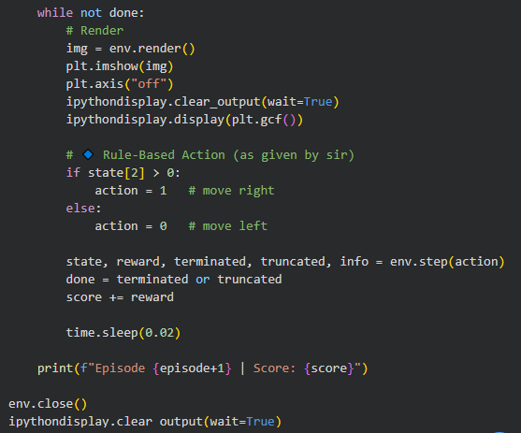
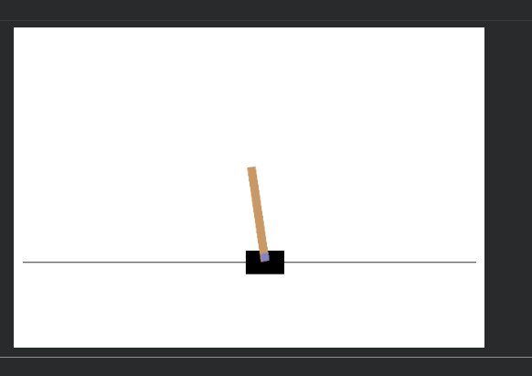

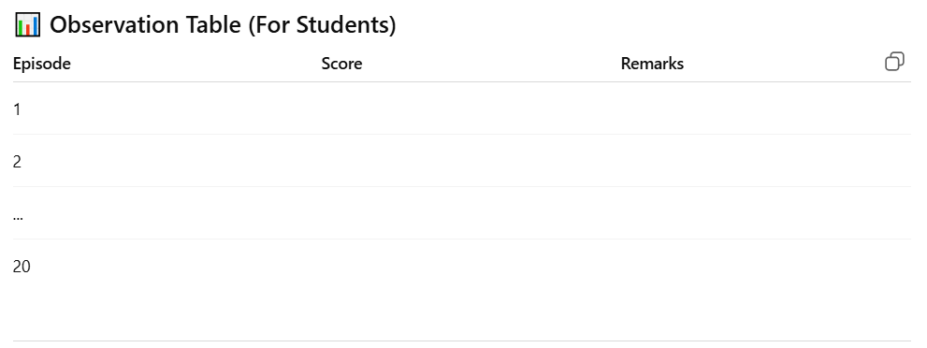
Observation Table For Students:
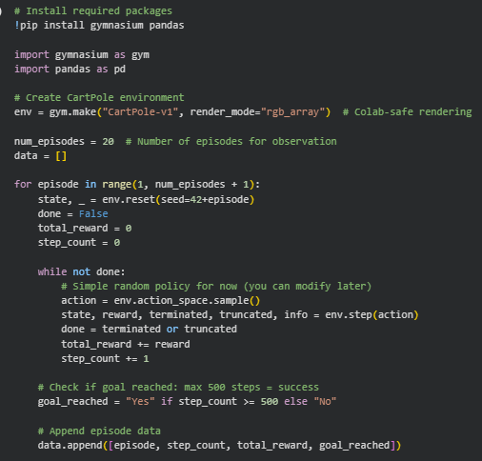
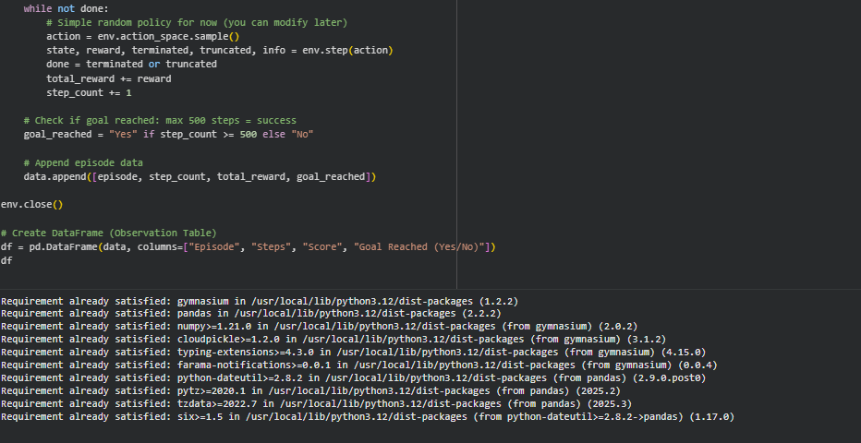
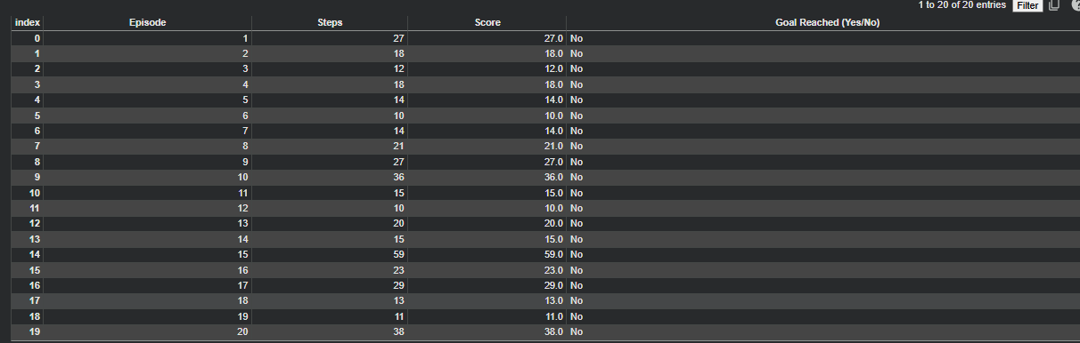

Experiment: MountainCar Environment using Gymnasium & Pygame
Lab Objectives
After completing this lab, students will be able to:
- Understand the working of a continuous control RL environment
- Analyze delayed reward problems
- Use Gymnasium MountainCar-v0
- Visualize agent behavior and rewards using Pygame
- Compare MountainCar with CartPole environment

Provided Code:
import gymnasium as gym
import pygame

env = gym.make("MountainCar-v0", render_mode="human")

font = None

for episode in range(1, 20):
state, info = env.reset()
done = False
score = 0

while not done:
action = env.action_space.sample()
state, reward, terminated, truncated, info = env.step(action)
done = terminated or truncated
score += reward

if font is None:
pygame.font.init()
font = pygame.font.SysFont("Arial", 24)

surface = pygame.display.get_surface()
text = font.render(f"Episode: {episode} Score: {int(score)}", True, (255, 0, 0))
surface.blit(text, (10, 10))
pygame.display.update()

print(f"Episode {episode} Score: {score}")

env.close()
pygame.quit()

Lab Questions (Conceptual Understanding)
Q1.
What is Reinforcement Learning? Identify the agent, environment, state, action, and reward in the MountainCar code.
Answer:

Reinforcement Learning
Reinforcement Learning is a learning approach in which an agent learns by interacting with an environment. The agent takes actions, observes the resulting state, and receives rewards. The objective is to learn a strategy that maximizes cumulative reward over time.

Identification Table
Component | Description in MountainCar
Agent | The program controlling the car
Environment | MountainCar-v0
State | Car position and velocity
Action | Push left, no push, push right
Reward | −1 at every time step

Q2.
Explain the purpose of the following statement:
env = gym.make("MountainCar-v0", render_mode="human")
Answer:
This statement creates the MountainCar environment using the Gym library. The render_mode="human" option enables graphical visualization, allowing the user to observe the car moving between the hills on the screen.
Q3.
What are the state variables in MountainCar-v0? What does each state represent?
Answer:
In the MountainCar-v0 environment, the state describes the current situation of the car at any given moment. The agent uses this state information to decide which action to take next. The state consists of two continuous variables that together explain where the car is and how it is moving on the track.

State Variables Table
State Variable | What it Represents
Position | The horizontal location of the car between the two mountains
Velocity | The speed and direction at which the car is moving

Q4.
Describe the action space of MountainCar-v0. How many actions are available and what do they mean?
Answer:
The action space in MountainCar-v0 defines all the possible moves the agent can make to control the car. The agent can apply force in different directions or choose not to apply any force. These actions influence the car’s movement and help it build momentum to eventually reach the goal at the top of the mountain.

Action Space Table
Action Value | Meaning
0 | Apply force to move the car toward the left side
1 | Do not apply any force and let the car move naturally
2 | Apply force to move the car toward the right side
Total actions available: 3
These three actions give the agent complete control over the car’s motion, allowing it to switch directions strategically to gain enough momentum to solve the task.

Q5.
Explain the reward mechanism in MountainCar-v0.
Why does the agent receive a negative reward at each step?
Answer:
In MountainCar-v0, the agent receives a reward of −1 at every step until it reaches the goal. This negative reward encourages the agent to solve the problem in the minimum number of steps. The environment is designed this way to penalize slow or inefficient behavior.
Q6.
What is the difference between:
terminated
truncated
in this environment?
Answer:
Aspect | terminated | truncated
Ending reason | Car reaches the goal position | Maximum step limit is reached
Goal achieved | Yes | No
Indicates success | Yes | No
Based on environment logic | Yes | No
Learning signal | Shows task completion | Shows time constraint

Q7.
Why does the agent fail to reach the goal when using action_space.sample()?
Answer:
When using action_space.sample(), the agent selects actions randomly. MountainCar requires a specific strategy involving momentum buildup. Random actions fail to create sufficient momentum, so the car cannot reach the goal at the top of the hill.
Q8.
Explain the role of momentum in solving the MountainCar problem.
Answer:
Momentum is essential because the car’s engine is not powerful enough to climb the hill directly. The agent must move back and forth to build velocity. This accumulated momentum allows the car to eventually reach the goal position at the top of the hill.
Lab Tasks (Hands-on Practice)
Task 1: Increase Episodes
Modify the code to run 50 episodes instead of 20.
Observe the score trend across episodes.
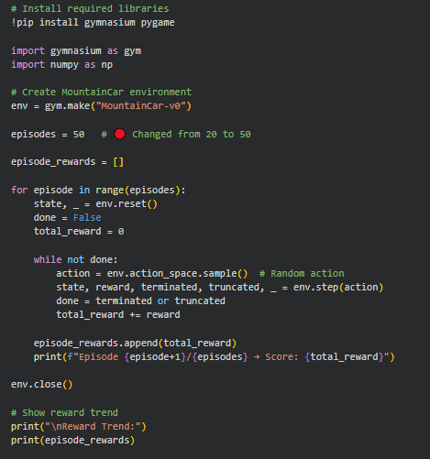
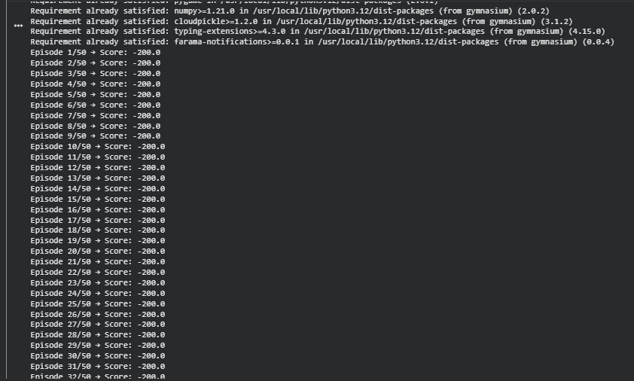

Task 2: Display State Values
Print the state array in each step and identify:
- Car position
- Car velocity
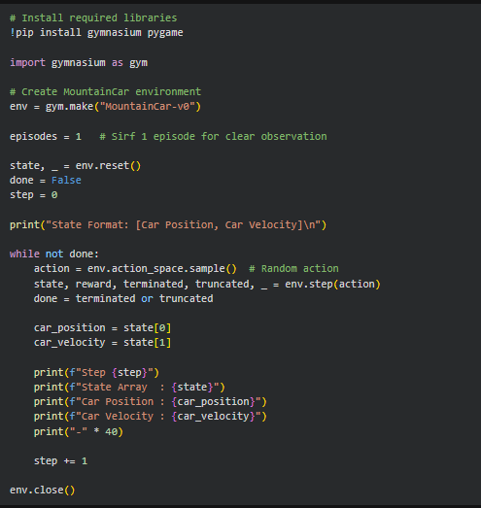
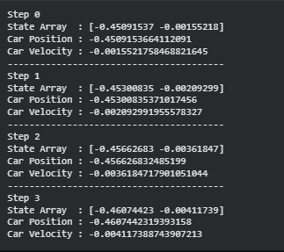
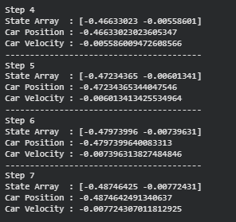
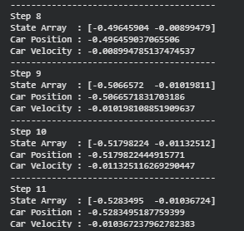
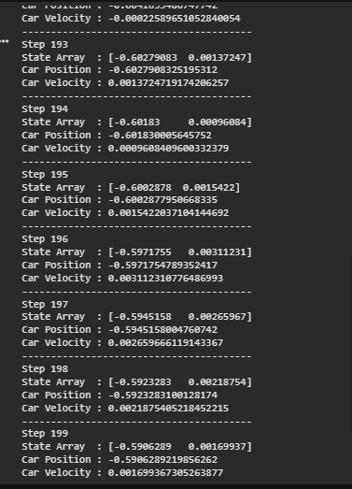
Task 3: Change Text Color & Location
- Change score color from red to blue
- Display text at position (200, 20)
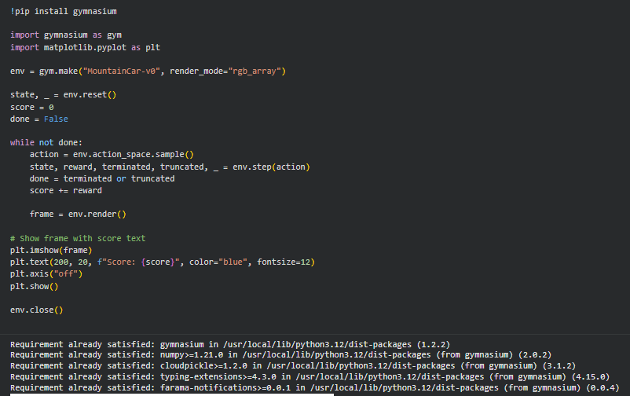
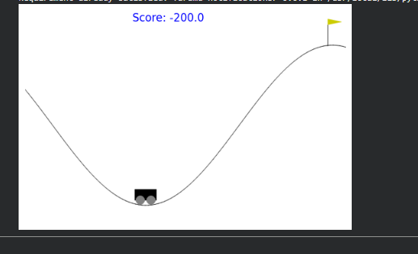
Task 4: Track Best Performance
- Store the score of each episode
- Print the best (highest) score at the end
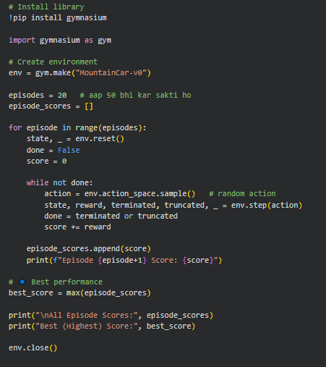
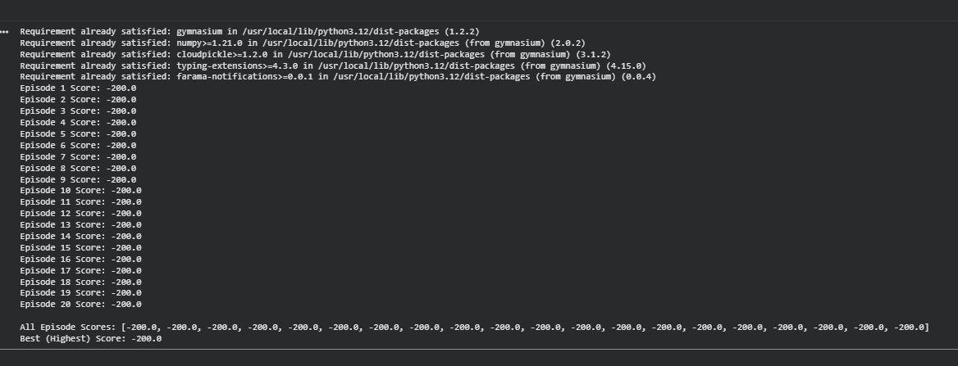
Task 5: Slow Down Visualization
Add the following line inside the loop:
pygame.time.delay(20)
Observe the change in animation speed.
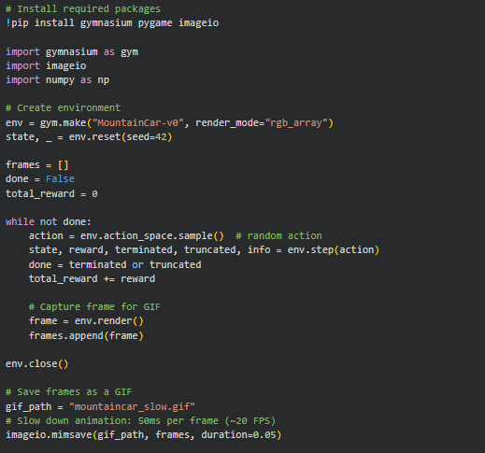
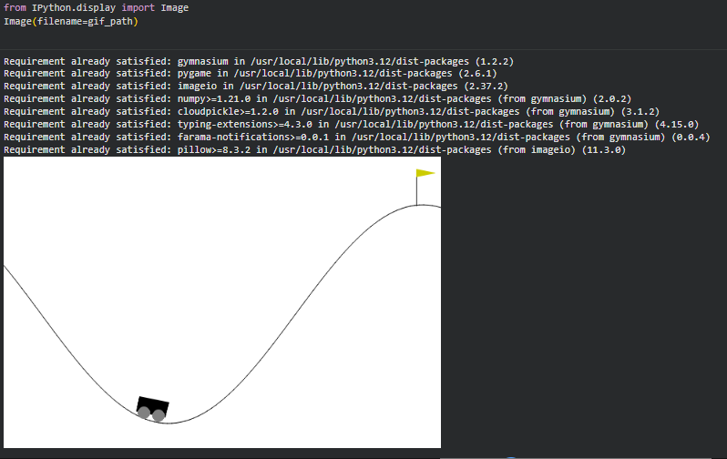
Task 6: Compare with CartPole
Replace the environment with:
env = gym.make("CartPole-v1", render_mode="human")
Compare:
- Reward behavior
- Episode termination
- Learning difficulty
Feature | MountainCar-v0 | CartPole-v1
Reward behavior | Sparse: -1 per step until reaching the goal → harder to learn | Dense: +1 per step while pole is balanced → easier feedback
Episode termination | Ends when car reaches top of hill or max steps | Ends if pole falls too far or max steps reached
Learning difficulty | Harder: requires momentum, trial-and-error | Easier: straightforward control, dense rewards
Visualization | Slow, physics-based | Pole moves quickly, requires fast balancing

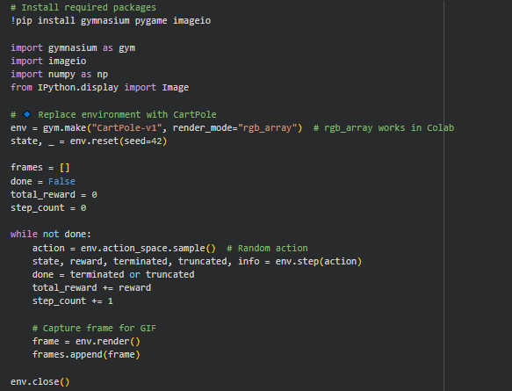
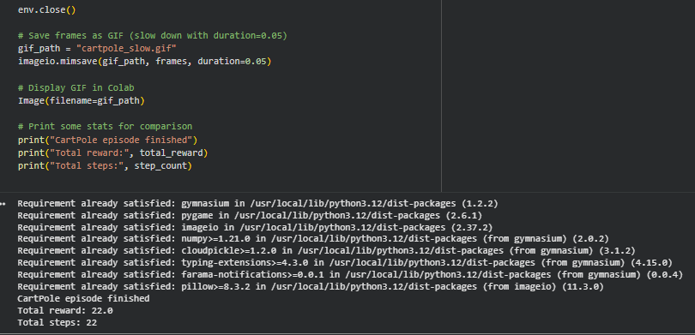
Task 7: Simple Rule-Based Policy (Intermediate)
Replace random actions with:
if state[1] > 0:
action = 2
else:
action = 0
Observe whether the agent reaches the hilltop.
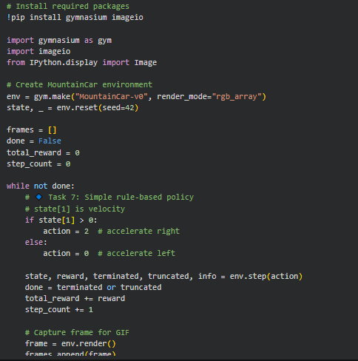
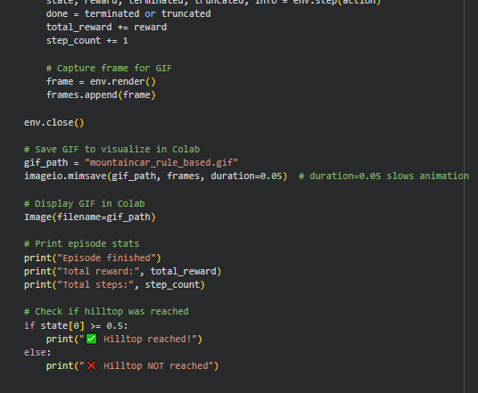
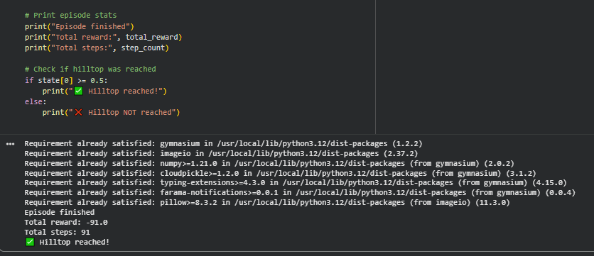
Task 8 (Advanced): Episode Length Analysis
Print the number of steps per episode and analyze:
- Why some episodes last longer
- Relation between steps and score
